IOWAGRANTS SITE SUPERVISOR TIMEKEEPING

*Site supervisors will approve member timesheets in the Time Sheet section of IowaGrants.

Site supervisors must be registered in IowaGrants, be associated with the correct grant and have the correct role to be able to access timekeeping. Please verify with the supervisor that they have completed the registration process if they are unable to view the timesheet component.

TO APPROVE MEMBER TIMESHEETS
1. Click on Individual Time Sheets.
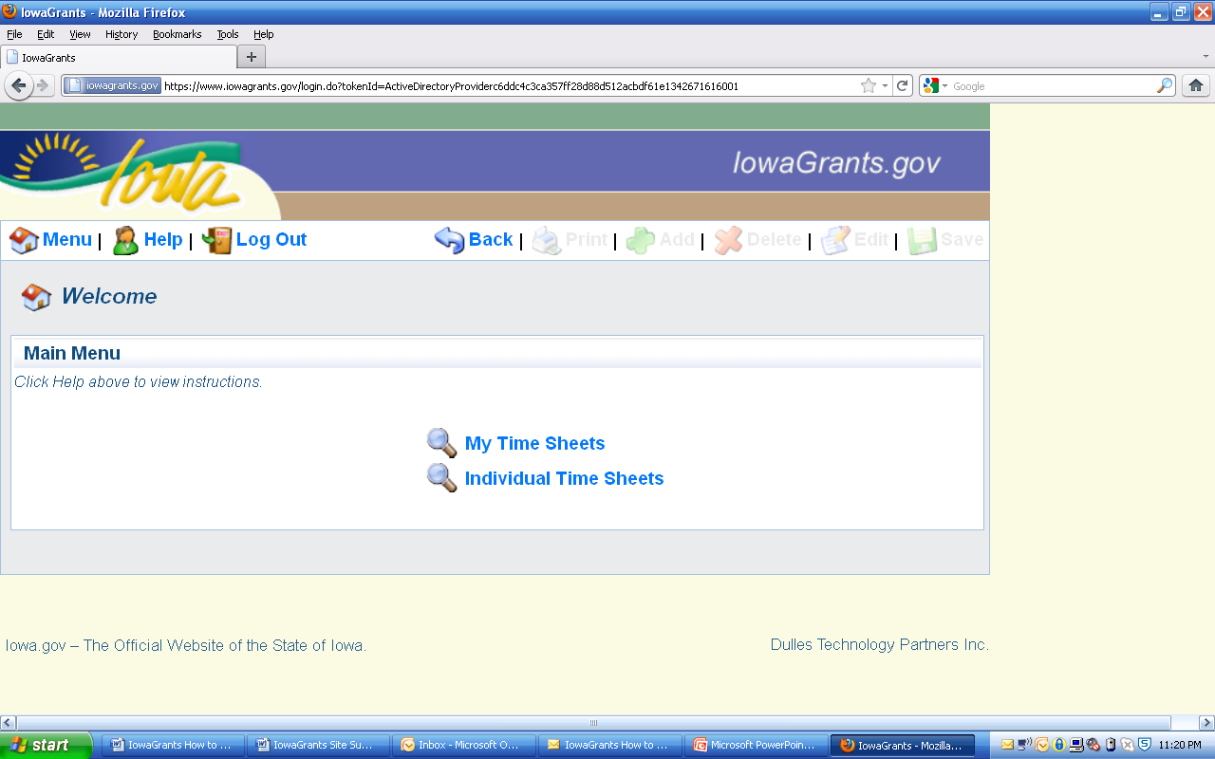
APPROVE MEMBER TIMESHEETS
OWN TIMESHEET

*Site supervisors will not be keeping their own time in the system this year. Site supervisors using time as match to the grant should contact the program director to ensure that they are maintaining signed paper timesheets that are in compliance with federal requirements. (While the columns for supervisors still appear in the system, they will be shut off on 12/1/13.)

2. Click on View to access the member time sheets by member. **NOTE: Site supervisors should receive email notification when member timesheets are submitted in the system.
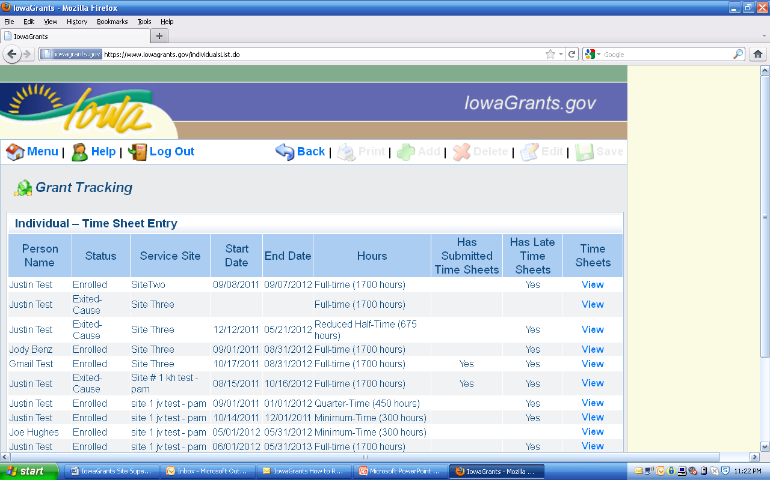
Note: Column indicates that there are submitted timesheets awaiting approval.
Note: Indicates late timesheets.
Click view

3. Click on View.
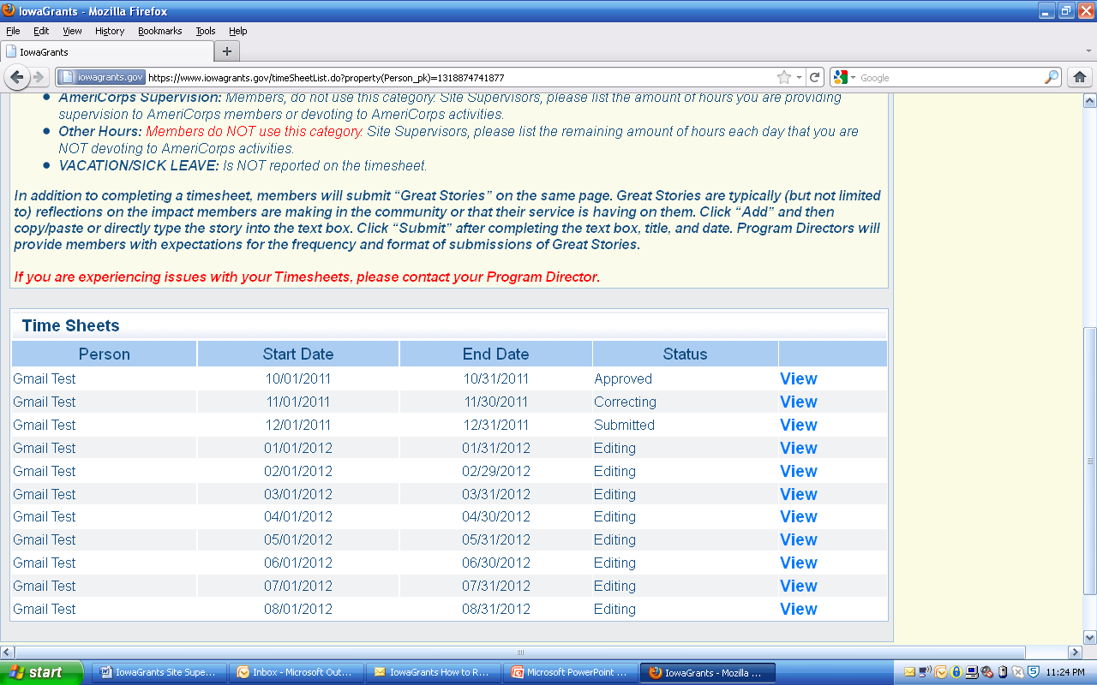
Note: timesheets labeled as submitted are available for approval.
Correcting and editing timesheets must be submitted by the member
Approved have already been approved.
DO NOT approve any member timesheets that show hours in “supervision” or “other” categories.
4. Verify the member hours. If correct, click Approve. If not, click Unlock.
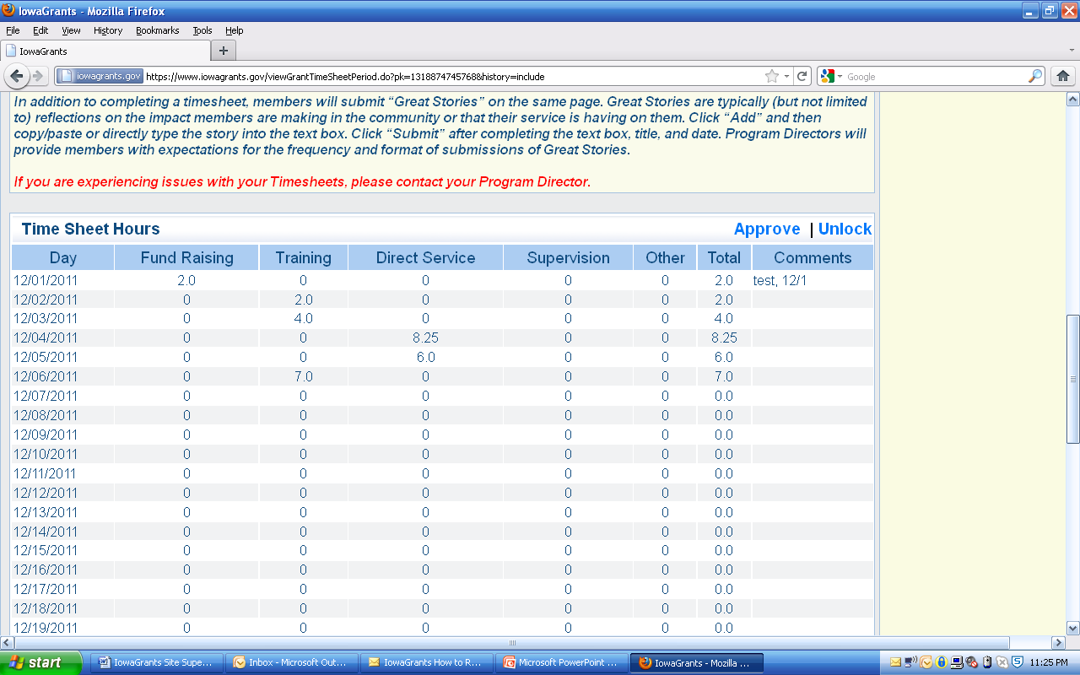
Note: Members should have hours only in the first three columns. No hours in supervision or other.
Note: If an error is discovered in a member’s timesheet after the site supervisor approves it, they will need to work with the program director to have the timesheet reopened. Only ICVS Program Officers have the ability to reopen approved timesheets.

5. Click okay to proceed. Click cancel to return to time sheet.
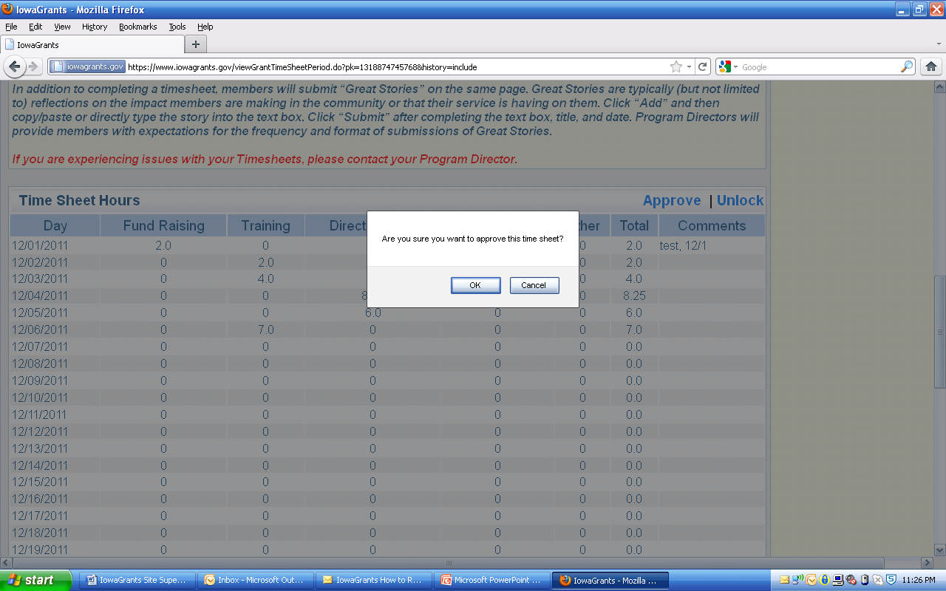

6. After the timesheet is approved, this screen will appear.
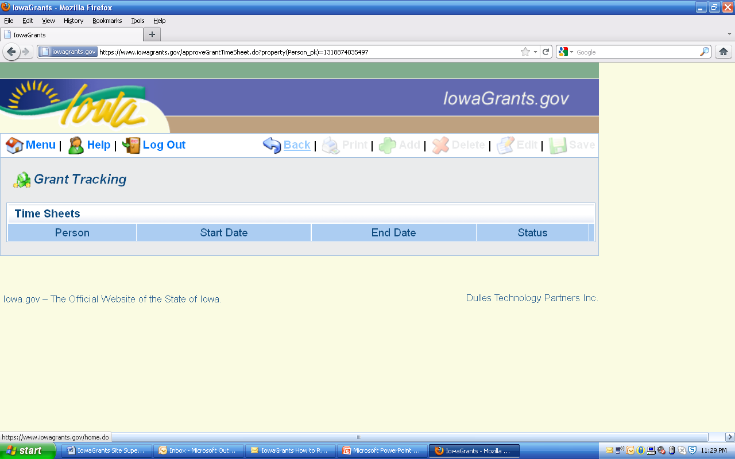

If you return to the member menu, you can see that the timesheet has been approved.
